# EverHustle

Submitted in partial fulfillment of the requirements of the degree

### BACHELOR OF ENGINEERING IN COMPUTER ENGINEERING

By

**Chirag Mahajan (1902088)**

**Aniket More (1902103)**

**Shyren More (1902104)**

Supervisor

**Dr. Jayant Gadge**



**Computer Engineering Department Thadomal Shahani Engineering College**

**Bandra(w), Mumbai - 400 050**

## University of Mumbai

**(AY 2020-21)**

# CERTIFICATE

This is to certify that the Mini Project entitled **“ EverHustle ”** is a bonafide work of **Chirag Mahajan (1902088), Aniket More (1902103), Shyren More(1902103)** submitted to the University of Mumbai in partial fulfillment of the requirement for the award of the degree of **“Bachelor of Engineering”** in **“Computer Engineering” Work**

#### (Prof. Jayant Gadge)

Supervisor

#### (Prof. Tanuja Sarode ) (Prof. G.T.Thampi)

Head of Department Principal

# Mini Project Approval

This Mini Project entitled “**EverHustle”** by **Chirag Mahajan (1902088), Aniket More (1902103), Shyren More(1902103)** is approved for the degree of **Bachelor of Engineering** in **Computer Engineering.**

**Examiners**

**1………………………………………**

(Internal Examiner Name & Sign)

#### 2…………………………………………

(External Examiner name & Sign)

Date:

Place:

# Contents

#### Abstract ii

#### Acknowledgments iii

#### List of Figures iv

#### Introduction 1

* 1. Introduction
  2. Motivation
  3. Problem Statement & Objectives
  4. Organization of the Report

1. **Literature Survey 11**
   1. Survey of Existing System
   2. Limitation Existing system or research gap
   3. Mini Project Contribution

#### Proposed System (eg New Approach of Data Summarization ) 18

* 1. Introduction
  2. Architecture/ Framework
  3. Algorithm and Process Design
  4. Details of Hardware & Software
  5. Experiment and Results
  6. Conclusion and Future work.

**References 32**

# Abstract

# The COVID19 pandemic has contributed to a huge amount of unemployment and unproductive habits in day-to-day lives. It can be very hard to seek help since most people need help themselves

# A platform can be created to serve this need where people can have different ways of enhancing their productivity such as concise notes, date-wise reminders, goals that can be categorized as daily, weekly, monthly, timer for keeping track of productive time, articles to boost the morale of the user by suggesting articles on productivity, self-help, and motivation.

# 

# List of Figures

# 3.1 Block Diagram 5

# 3.1 Database Design 6

# 

# Acknowledgement

We would like to express our gratitude and thanks to **Dr. Jayant Gadge** for her valuable guidance and help. We are indebted for her guidance and constant supervision as well as for providing necessary information regarding the project. We would like to express our greatest appreciation to our principal **Dr. G.T. Thampi** and the head of the department **Dr. Tanuja Sarode** for their encouragement and tremendous support. We take this opportunity to express our gratitude to the people who have been instrumental in the successful completion of the project.

Chirag Mahajan

Aniket More

Shyren More

# Chapter 1

## Introduction

This chapter explains the aim, objectives, and scope of the proposed system.

### Introduction

EverHustle is an open-sourced productivity web application that tries to help society with various ways of boosting their productivity

### Motivation

* This pandemic has resulted in a drop in productivity for most people, they are not accustomed to doing  ‘work from home.
* A drive to **create something useful for other people**.
* There is no single web app for all the required productivity tools
* EverHustle has been developed by considering the above points

### Problem Statement & Objectives

Problem statement:

* This pandemic has resulted in a drop in productivity for most people, they are not accustomed to doing  ‘work from home.
* Also, there is no single web app for all the required productivity tools
* EverHustle serves this exact purpose

Objectives: To design and develop an efficient and responsive application with the following features:

* Notes
* Reminders(via email)
* Set daily, weekly, monthly goals
* Timer
* Articles

### Organization of the Report

This report consists of three chapters. The first chapter deals with introduction of the topic, problem statement, motivation behind the topic and objectives. The second chapter is the Literature Survey. It includes all the research work done related to this topic. All information related to study of existing systems as well as learning of new tools is mentioned in this chapter. The third chapter is about the proposed system which is used in this project. The block diagram, techniques used, hardware and software used screenshots of the project are presented in this chapter. All the documents related to the development of this project are mentioned in the References

# Chapter 2

## Literature Survey

This chapter explains the concepts used in this project, study of existing system and contribution of this project

### Survey of Existing System

Following are some of the popular Web applications having similar features:

1. Todoist: Todoist is a task management tool that promises to turn complex to-do lists into something easily manageable.

You can create and organise tasks, set and change deadlines, prioritise tasks, set project goals and keep track of progress with the app’s measurement and has reporting features.

1. Serene: Available for macOS

Serene can help you get organized but the platform is also designed to improve your working habits. The software encourages you to work in short power bursts to maximize productivity and studies have shown this approach can increase your concentration levels while reducing fatigue.

1. EverNote: Evernote is a powerful tool for managing your tasks right alongside all of the information you work with every day,

Features of EverNote

* + Rich notes: Express ideas, capture images, and record audio in meetings or lectures, all from your phone or tablet—even if you’re offline.
  + Document scanning: Go paperless. Back up important documents to all your devices, and keep the information—not the clutter.

### Limitation of the existing system

While studying the existing system if you have come across any drawbacks or limitations then mention them

1. Most of the above-mentioned applications are specialized only for certain features eg: Todoist for managing tasks and EverNote for note-taking
2. Most systems are paid
3. Few of them lack accessibility

### Mini Project Contribution

Write about your own work. If you have attempted to solve any of the limitations mentioned in 2.2 then write about that or else you can write about how your system is different from the existing ones (difference can be in terms of technology used or any additional features included etc)

* As mentioned in section 2.1, EverHustle provides many features making it a true productivity app rather than just another note-taking application
* EverHustle is built on React.js which helps in making the application scalable
* EverHustle is completely free and supports the spirit of open-source
* The application also provides a user-friendly UI to improve ease of accessibility
* For keeping user mentally motivated and driven articles are also provided which is one of the distinguishing factors from other web applications

# Chapter 3

## Proposed System

### Introduction

Write about the programming language, tools, technology that you have used.

Technologies used in developing the application

Front-end: React.js, HTML, CSS, React-query, Reactstrap

Back-end: MongoDB, TypeScript, Express.js, Node.js

External APIs: Algolia search API

### Architecture

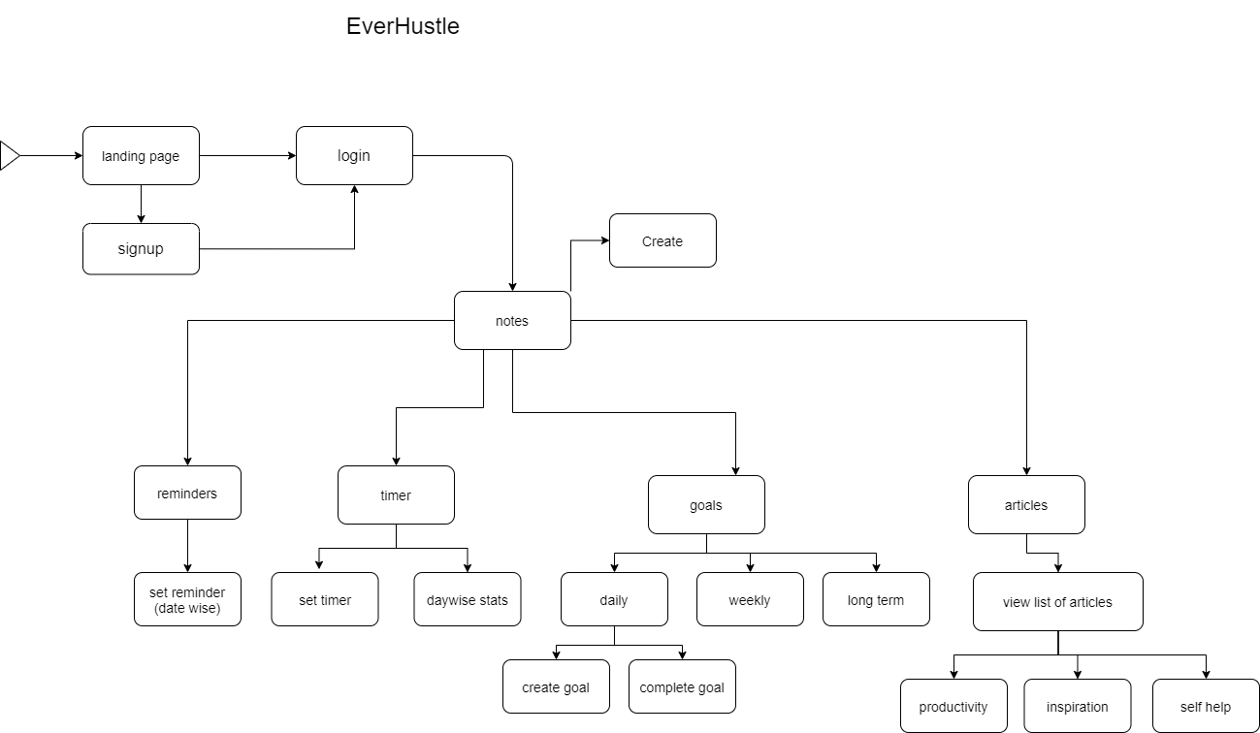

The above block diagram shows the working of the project and design of the website. The user logs into the website and then is redirected to notes, in this page user can create, delete and update **concise notes**.

The user can go then go to the reminder page when date-wise reminders could be made to remind the user via email.

The user can then move onto the timer page that keeps a track of its productive time. Afterwards, the user can go to the goals section, where goals can be categorized into daily, weekly, and monthly

Since the user must be also mentally fit, we are also providing an articles section based on topics productivity, self-help, and motivation.

### Algorithm and Process Design

Write a few lines for each of the steps given below. Mention what you have done in every step.

1. Formulating the Problem statement: Concerning section 2.1, the problem statement was formulated after extensive research about existing alternative systems
2. Understanding the framework and requirements: To build a scalable system React.js is used on the front-end side and Node.js on the back-end
3. Finalizing the features to be included:
4. Development
5. Testing
6. Evaluation

### Details of Hardware & Software

All you need is an internet browser and a stable internet connection

### Results

Put screenshots and write one line about each of them.

Landing page: The landing page gives an overview of the features

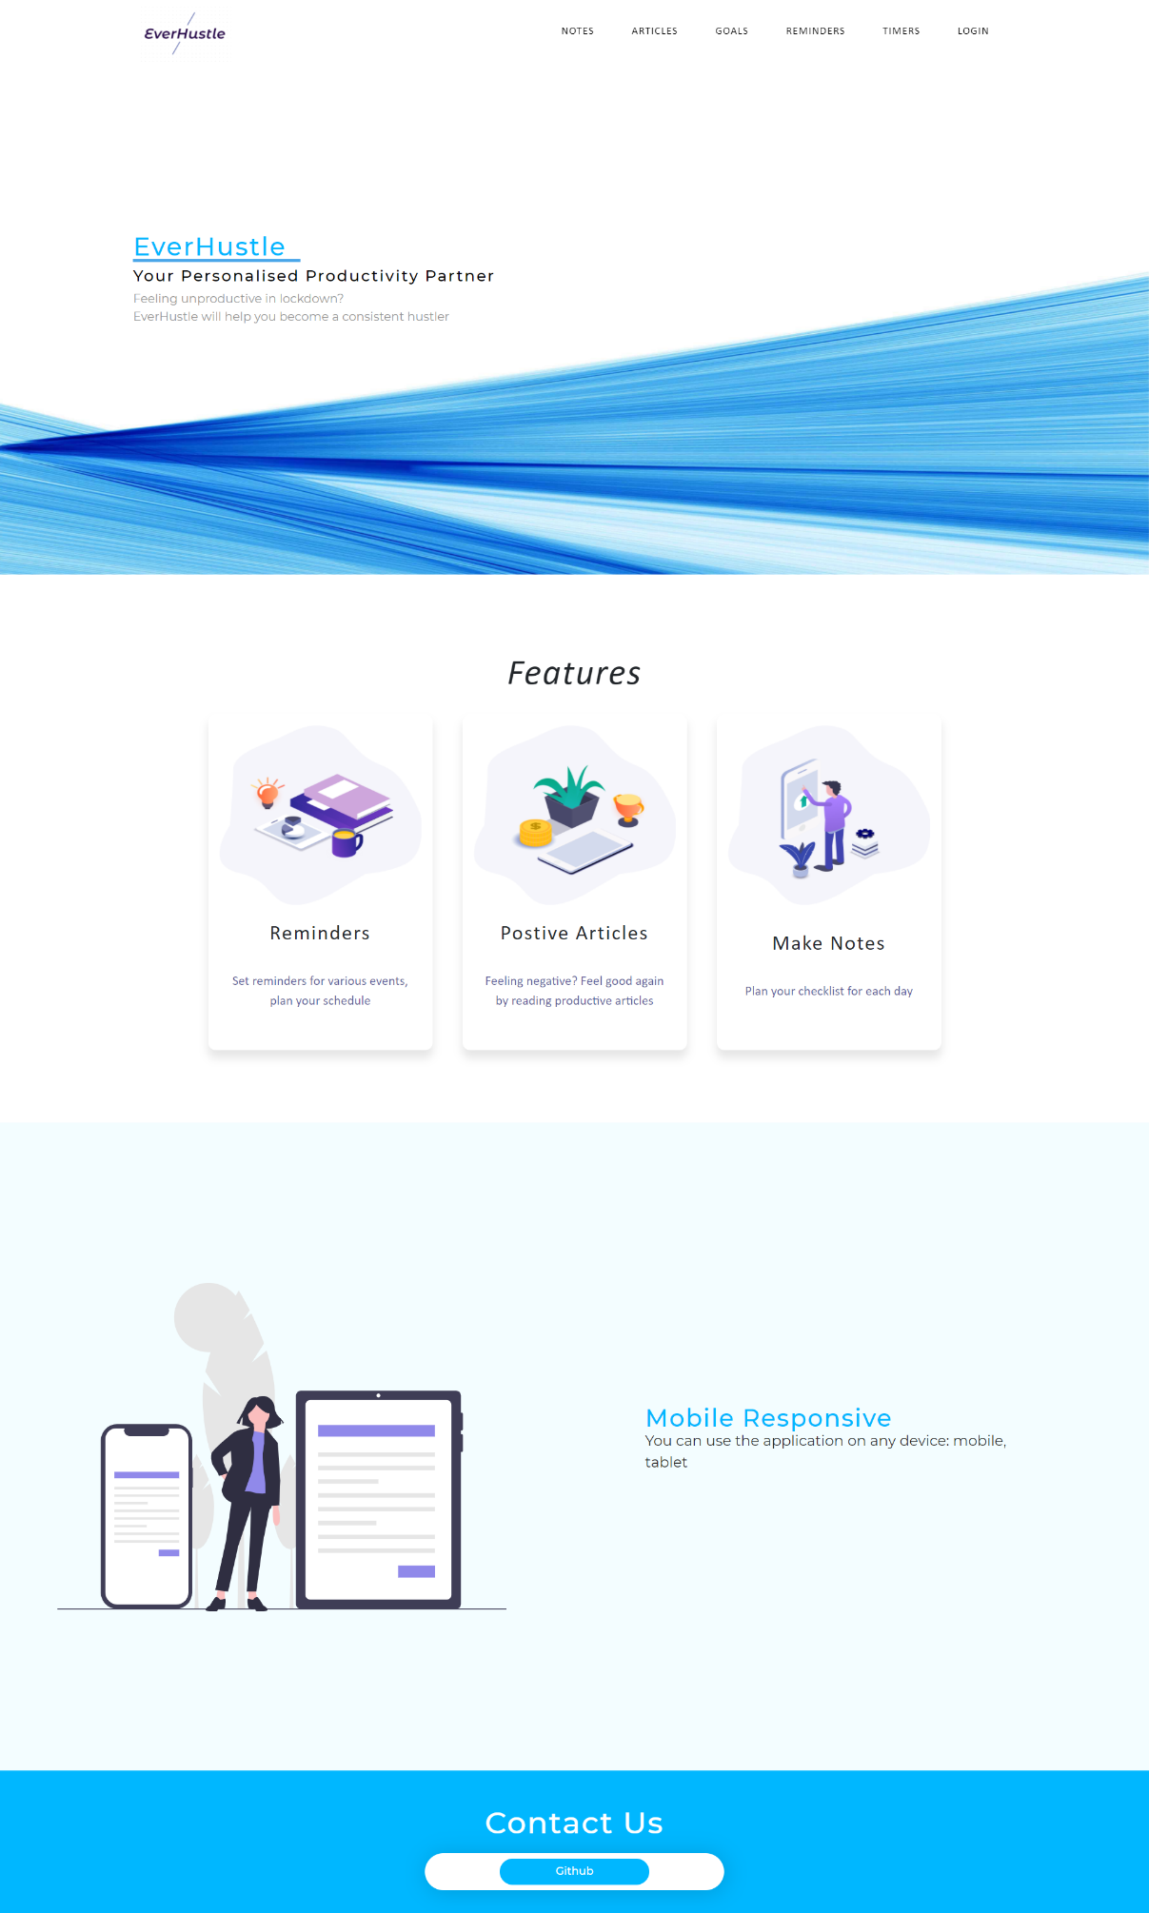

Login and Sign up:

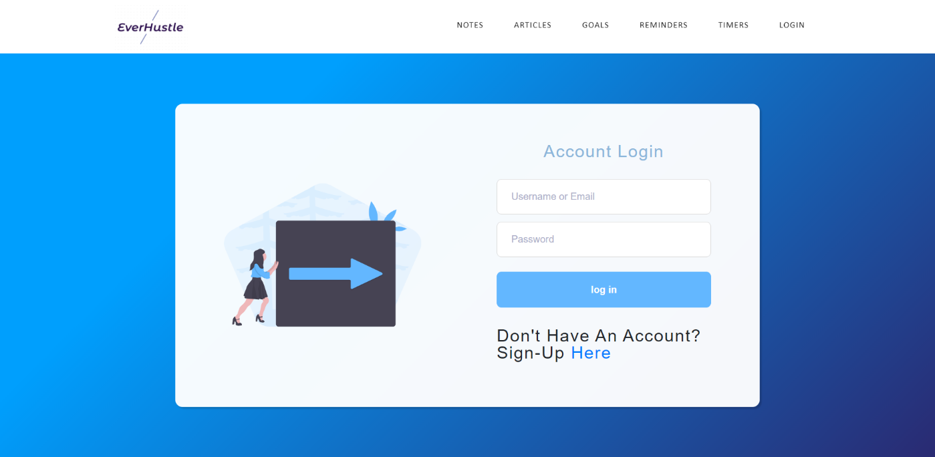

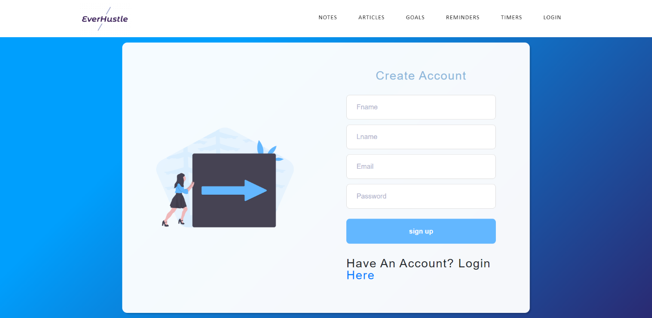

Articles:

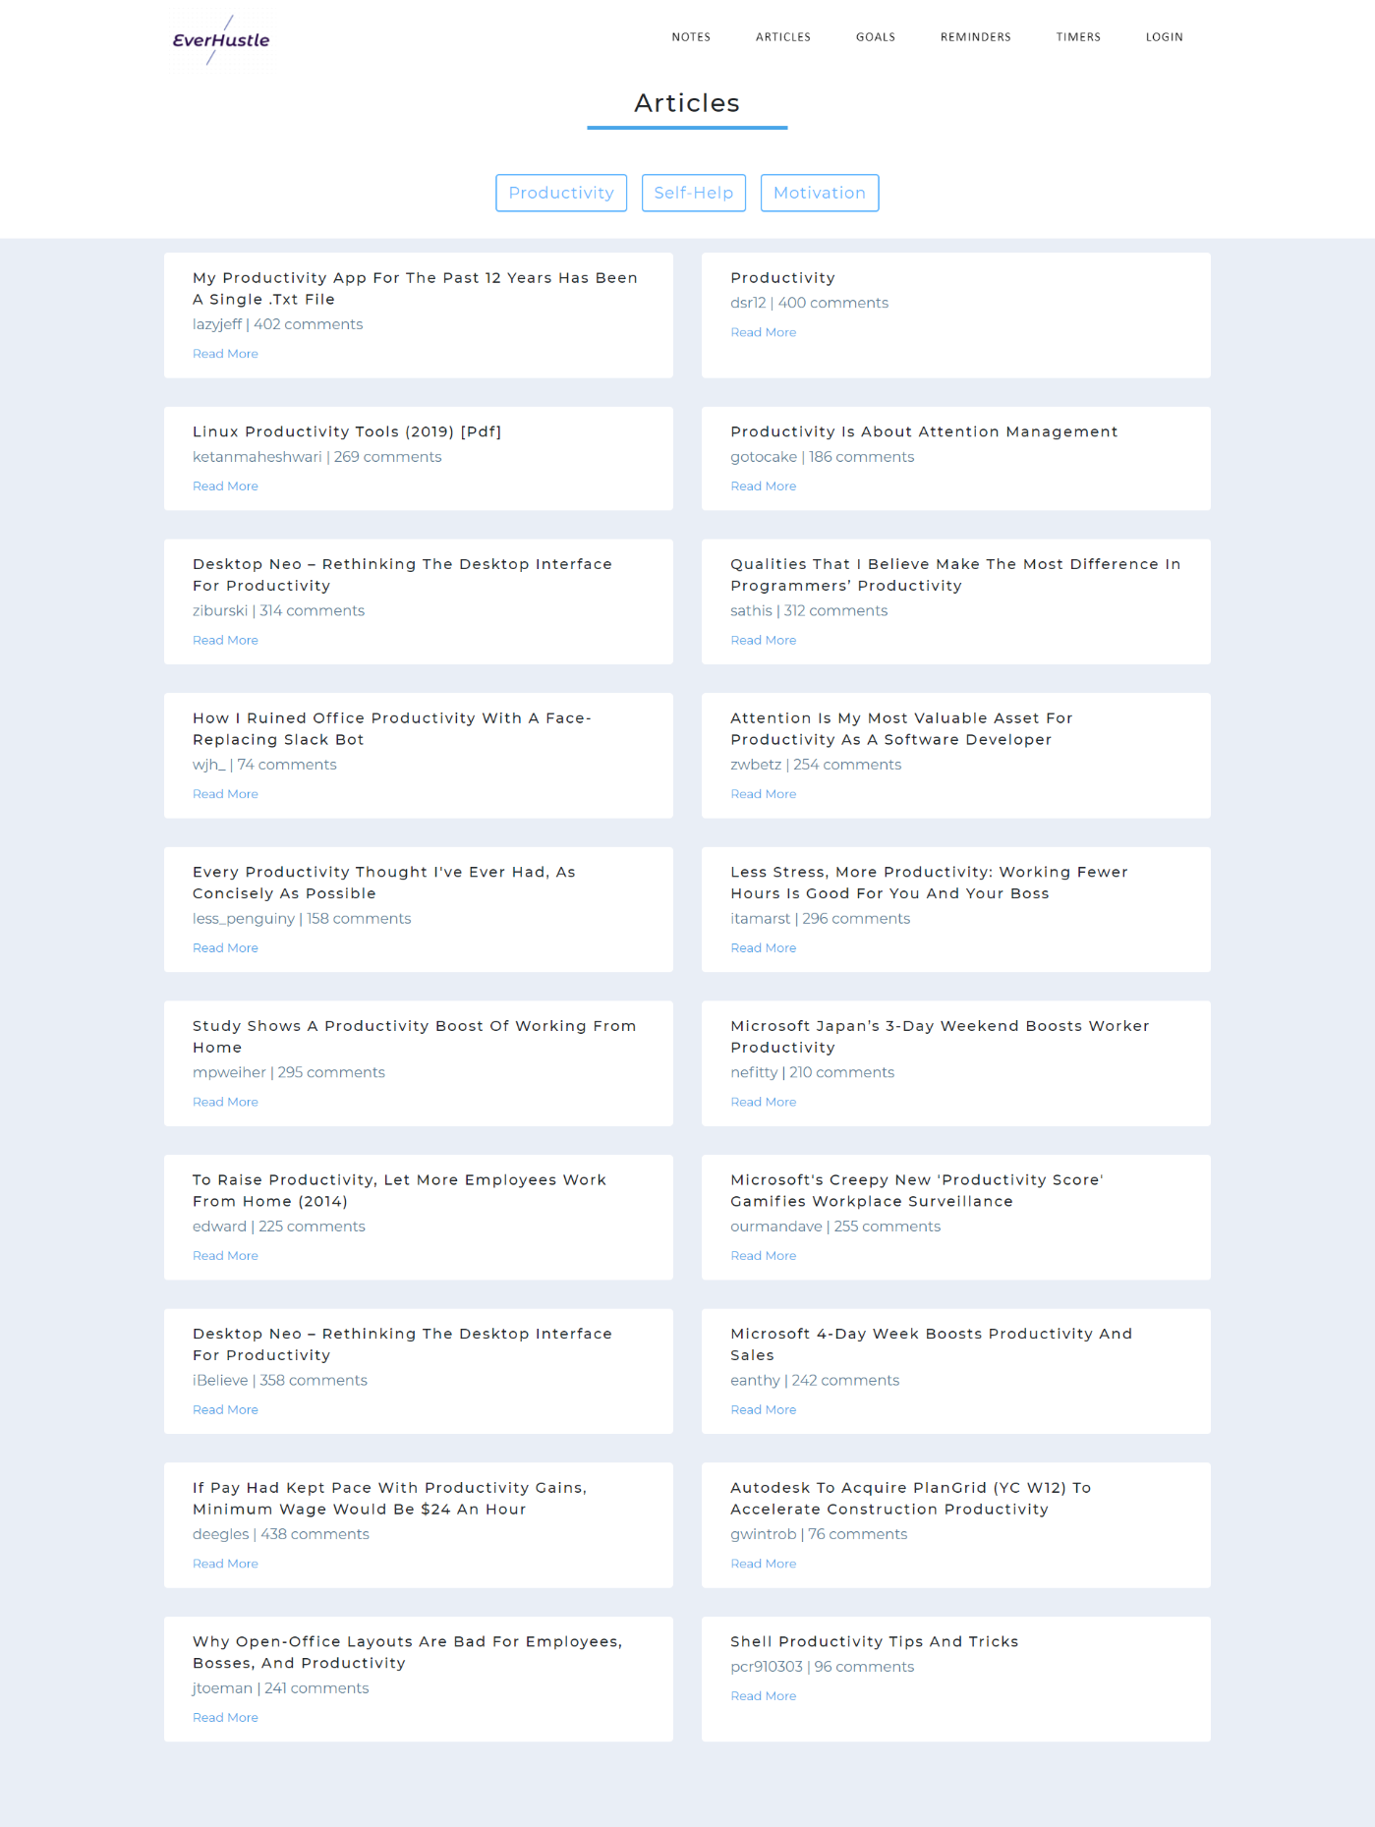

Goals:

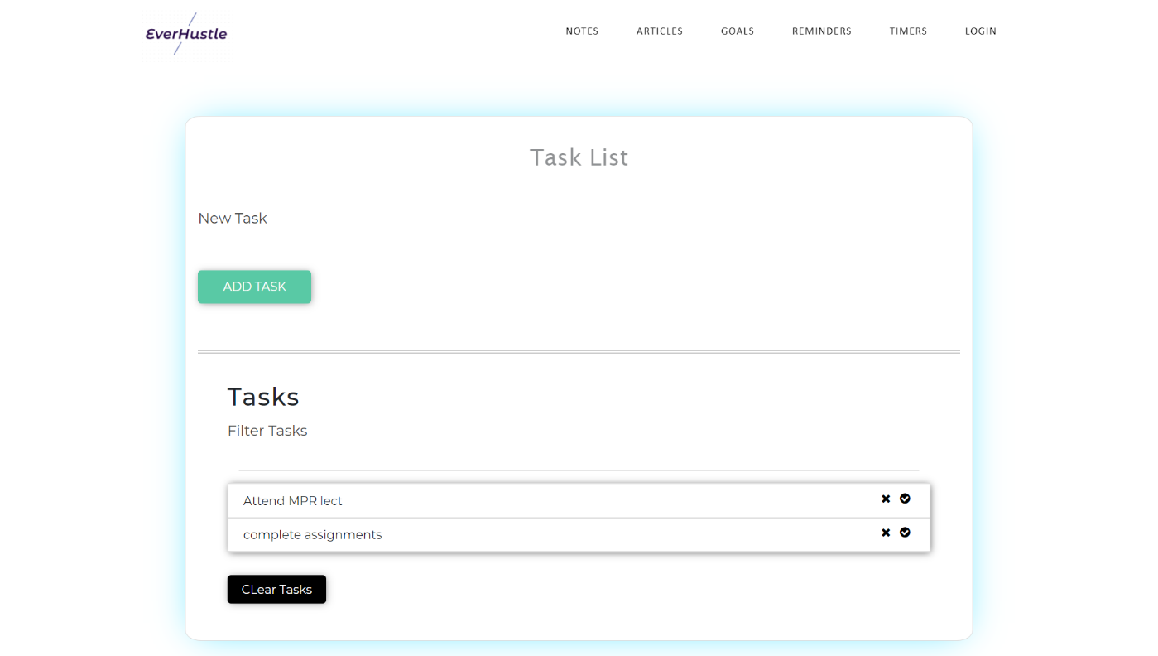

Notes:

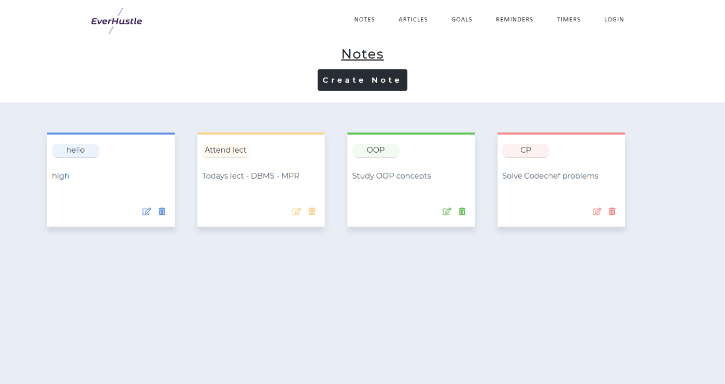

**3.6 Conclusion and future work**

Conclusion: An open-sourced web application is created that will boost people’s productivity and thereby help the society

Future work:

Make articles more personalized by using machine learning

### References

Format for references is given in this link: <https://libguides.murdoch.edu.au/IEEE/all>

Depending on what reference you are using, whether it is a video or any article from a website,you need to select that format from the given link

**Note:** For each reference you need to write the citation. Example: If any paragraph or sentence you are copying as it is from the internet then that needs to be cited. At the end of the statement write the citation number[1] then given full stop.

**Note:** Mention page numbers in bottom right corner of every page. Start the report from introduction. Make a separate document for the pages before introduction because they will be numbered in Roman Number. **Contents will be page i, abstract will be page ii, acknowledgements will be page iii, list of figures will be page iv**

No need for list of abbreviations, list of tables and list of symbols

**Note:** Try to write the whole report in your own words. Avoid copying from the internet.

**Note:** Font should be Times New Roman, Font size for headings will be 16, sub headings: 14, body: 12. Line spacing: 1.5